ASSIGNMENT – 05
Implementation of Various Scheduling Mechanisms Using an Open-Source Cloud Simulator.

STEP 01-Open and update Ubuntu.
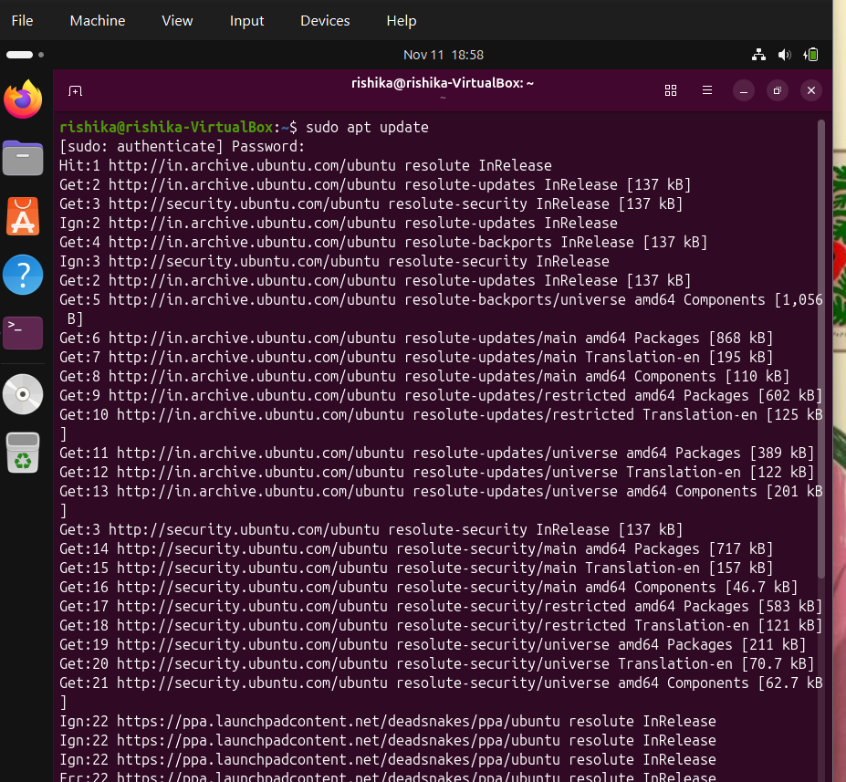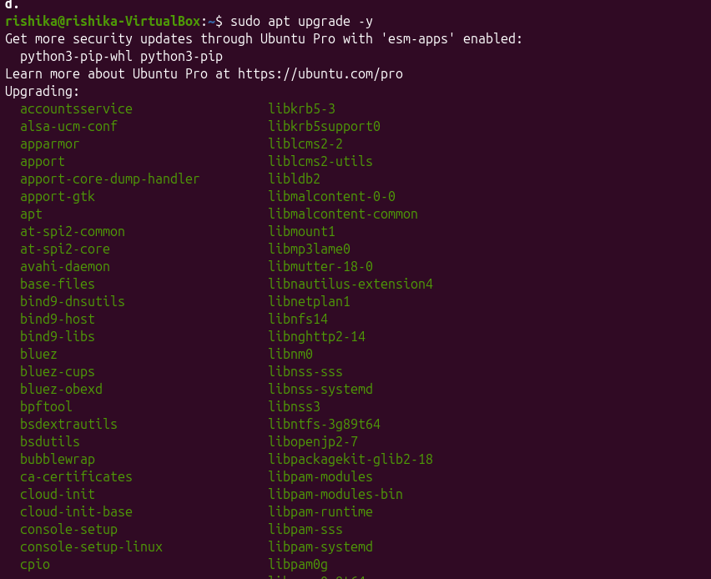

STEP 02- Install Java, Maven and Git
enter: sudo apt install openjdk-17-jdk maven git -y
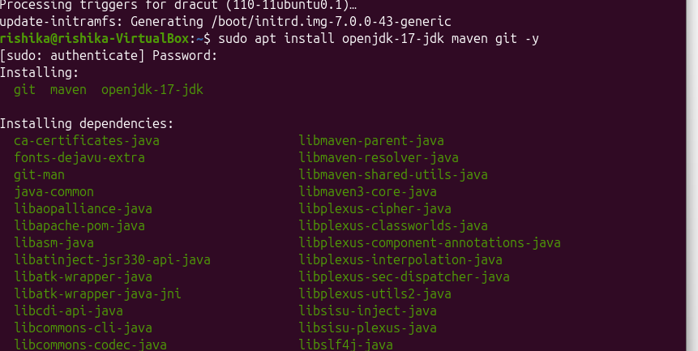
Wait until installation finishes.
Now verify the installations individually:
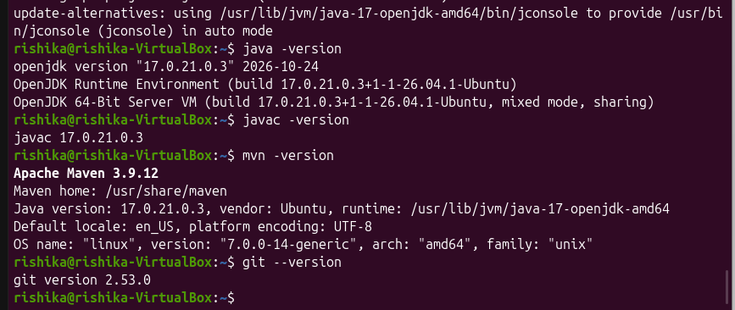

STEP 03- Create the CloudSim Plus project
We will create a Maven project named CloudSchedulingLab.
In the Ubuntu terminal, enter: mkdir -p ~/CloudSchedulingLab/src/main/java/lab
This creates the project folders.

Now enter: cd ~/CloudSchedulingLab
This takes you inside the project directory.
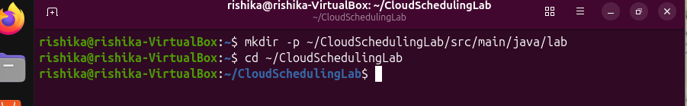

STEP 04- Create the Maven configuration file
In the same terminal, enter: nano pom.xml
This opens the Nano text editor, and now add the code.
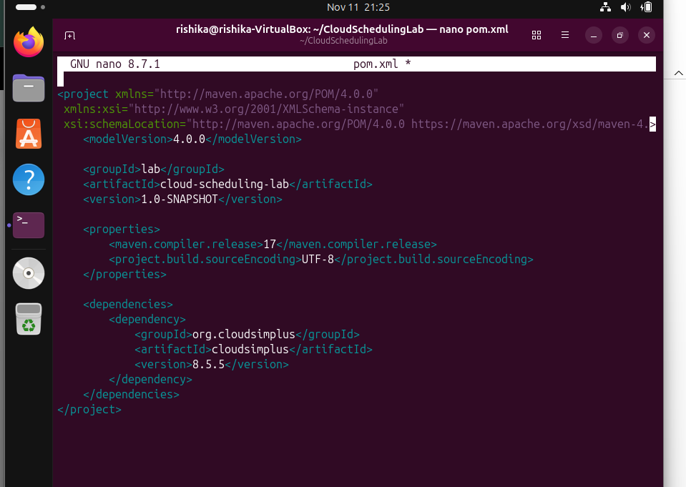

We created pom.xml, the Maven configuration file. It tells Maven which Java version and external library the project needs. CloudSim Plus is the simulator library used in this experiment.

STEP 05: Download CloudSim Plus dependencies
You should now be back in the Ubuntu terminal.
RUN: mvn dependency:resolve
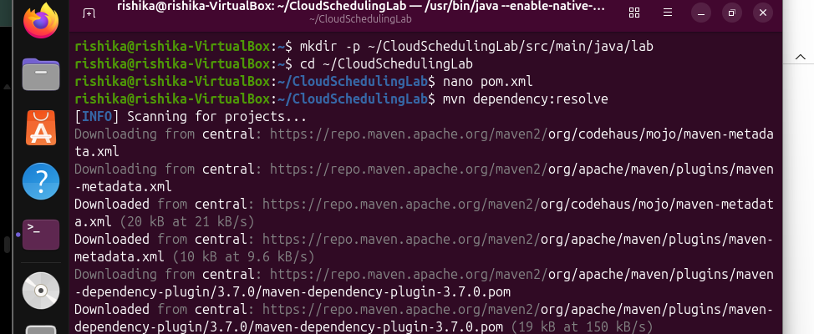
Wait for Maven to finish downloading the libraries.
Then execute: mvn clean
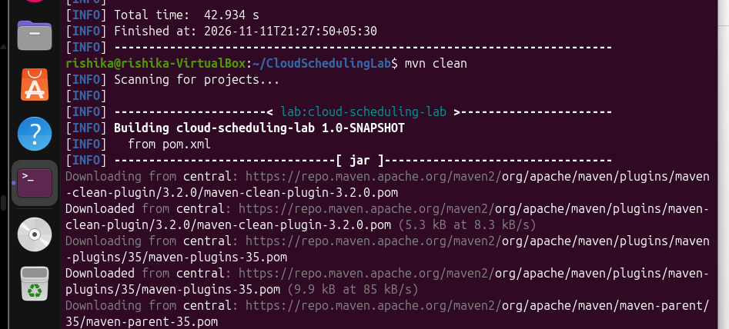
This removes previous build files so that the next compilation starts fresh.

STEP 06- Create the Java program
This is where you will write the actual scheduling simulation.
In the terminal, execute: nano src/main/java/lab/SchedulingExperiment.java
Nano will open a new blank file, and there we write our next code.
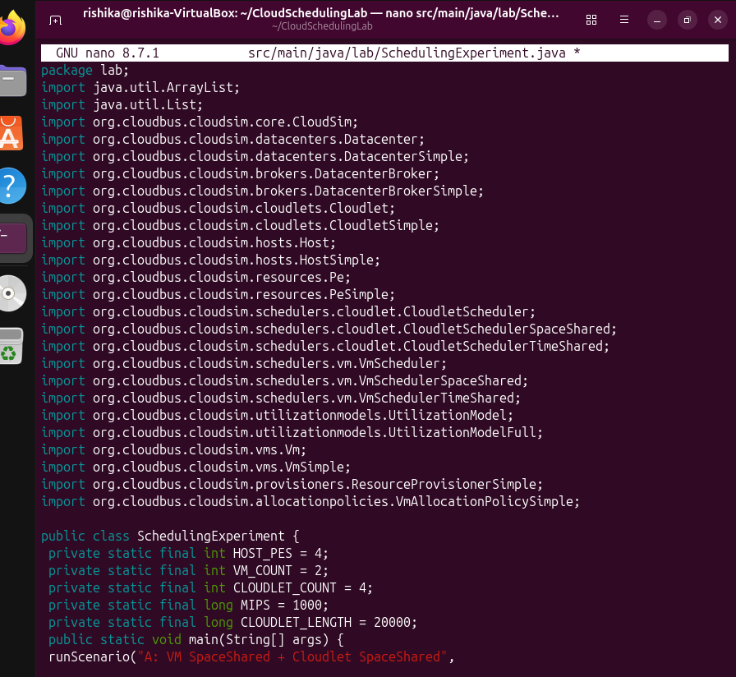
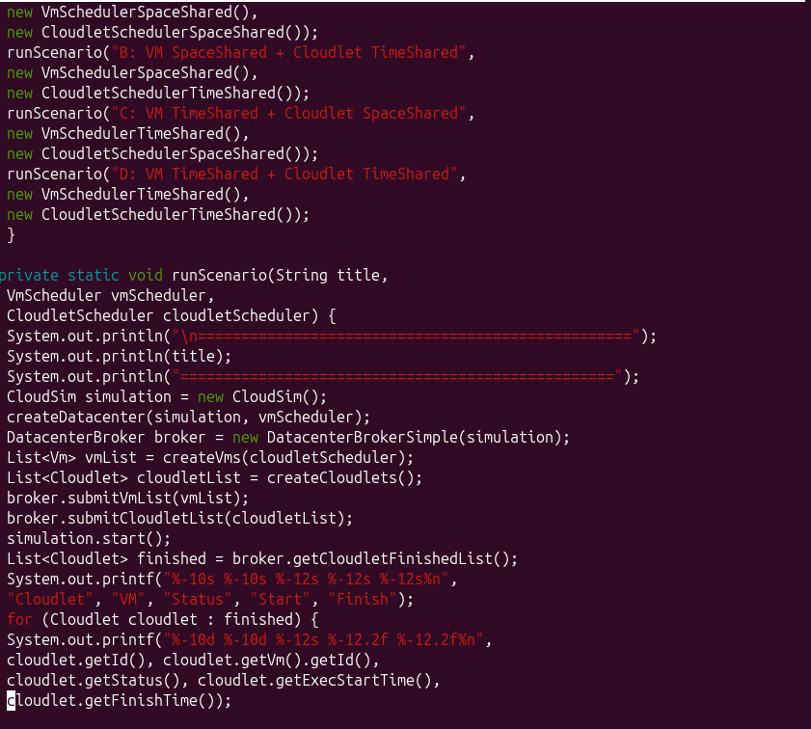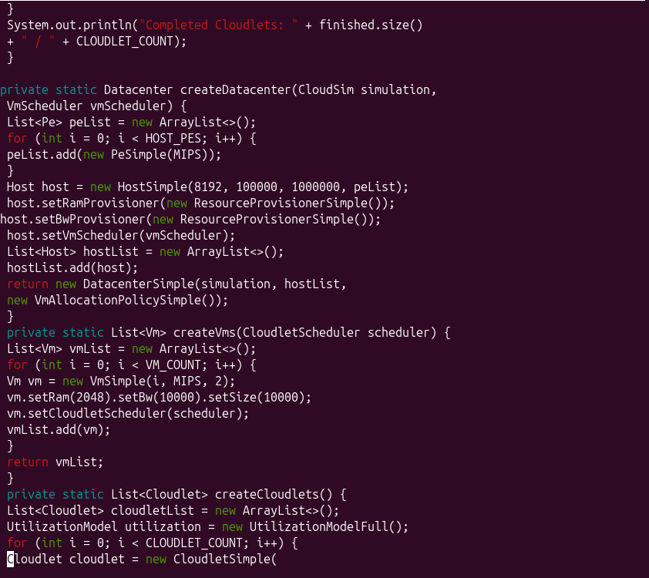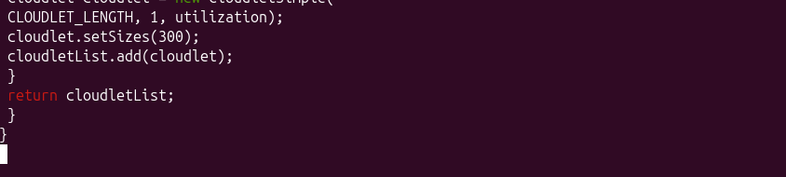
Component Purpose_______________________
CloudSim Creates and manages the simulation
Datacenter Represents the cloud infrastructure
Host Represents the physical server
VM Represents a virtual machine
Cloudlet Represents a task submitted for execution
DatacenterBroker Submits VMs and Cloudlets
VmScheduler Allocates CPU resources to VMs
CloudletScheduler Allocates VM CPU resources to Cloudlets
There are two levels of scheduling:
1. VM Scheduling
Determines how the host's processing resources (PEs) are allocated among virtual machines.
- Space Shared: Resources are exclusively allocated.
- Time Shared: Resources are shared among VMs.
2. Cloudlet Scheduling
Determines how CPU resources within a VM are allocated among Cloudlets.
- Space Shared: Cloudlets wait for available processing resources.
- Time Shared: Multiple Cloudlets share the available processing power.

STEP 07- Compile the Java program
Return to the terminal. Make sure you are inside ~/CloudSchedulingLab.
Run: mvn clean compile
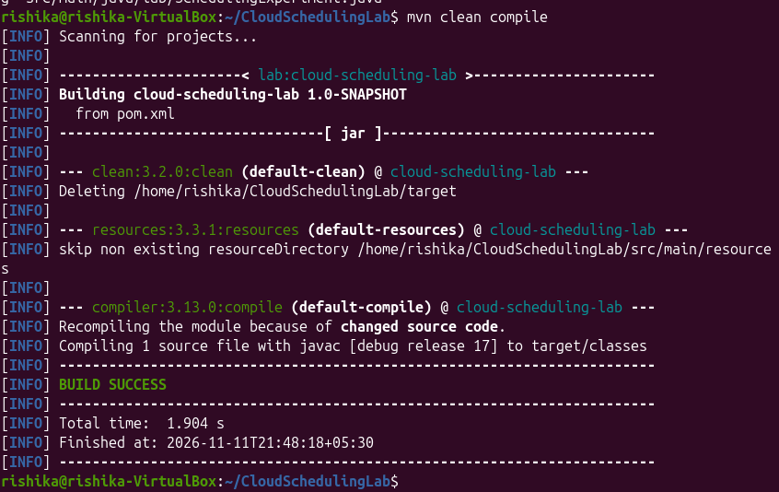
STEP 08- Run the program.
Enter: mvn exec:java -Dexec.mainClass="lab.SchedulingExperiment" -Dexec.classpathScope=compile


